**How to maximize storage efficiency post AFF ONTAP 9.x migration**

This article describes the steps that need to be followed to maximize storage efficiency after migrating the volumes from 7-Mode system to AFF ONTAP 9.x system or CDOT system to AFF ONTAP 9.x system, depending on the migration method used (7MTT, VMware vM

Nov 17, 2016•How To

ARTICLE NUMBER

DESCRIPTION

render facet: 37:180;a

PROCEDURE

Migration using 7MTT/Vol Move/SnapMirror – Execute these steps after the migration to new ONTAP 9 volumes is completed

* Ensure thin provisioning (space guarantee = none) is enabled on all the volumes. For newly created volumes, thin provisioning will be enabled by default

vol show -vserver $SVM_NAME -volume $VOL_NAME -fields space-guarantee,space-guarantee-enabled

vol modify -vserver $SVM_NAME -volume $VOL_NAME -space-guarantee none

* Ensure default inline efficiency is enabled on all the volumes. For newly created volumes, inline efficiency will be enabled by default.

vol efficiency show -vserver $SVM_NAME -volume $VOL_NAME

vol efficiency on –vserver $SVM_NAME –volume $VOL_NAME

vol efficiency modify -vserver $SVM_NAME -volume $VOL_NAME -compression true -inline-compression true -inline-dedupe  true -data-compaction true

* Existing snapshots might have blocks trapped in it with no savings realized. Such snapshots might need to be retired to gain additional savings.

Best Practice: Delete/Retire old snapshots that are no longer required, as these can lock blocks that might be reduced by compression.

volume snapshot show -vserver $SVM_NAME -volume $VOL_NAME

volume snapshot delete -vserver $SVM_NAME -volume $VOL_NAME -snapshot $SNAPSHOT_NAME

* Run background scanner to compress existing data in the volumes (Advanced mode command).

priv set advanced

volume efficiency start -vserver $SVM_NAME -volume $VOL_NAME -scan-old-data true -compression true –dedupe true

This will compress non-shared data in active filesystem. To compress shared blocks in active filesystem as well as blocks locked in snapshots, run the following command.

Note: Uncompressed blocks trapped in the snapshots are locked and cannot be changed. So, compressed snapshot blocks will consume additional space in the filesystem. Space savings from the locked blocks will be realized once the snapshots are deleted/expired.

Best Practice: It is not recommended to take any snapshots while the background scanner is running. If snapshots are taken while the background scanner is running, data trapped in snapshots will remain uncompressed (even after the snapshots are deleted/expired).

volume efficiency start -vserver $SVM_NAME -volume $VOL_NAME -scan-old-data true -compression true  -snapshot-blocks true -shared-blocks true –dedupe true

* Enable scheduled background deduplication on all volumes. You can use the system created ‘default’ background policy that runs every day at midnight on best-effort basis or create a custom policy and schedule.

Note: Ensure that dedupe schedule and snapshot schedule do not overlap and ensure that no snapshots are taken during last successful runtime of dedupe scanner.

For example, if dedupe run started at 12:00AM, and ran for five minutes, do not take snapshots between 12:00AM and 12:05AM. This will ensure that data does not gets trapped in snapshots.

volume efficiency modify -vserver $SVM_NAME -volume $VOL_NAME -policy default

-OR-

job schedule cron create -name dedupe_nightly -minute 10 -hour 0

volume efficiency policy create -vserver $SVM_NAME -policy dedupe_post -type scheduled -schedule dedupe_nightly -qos-policy background

volume efficiency modify -vserver $SVM_NAME -volume $VOL_NAME –policy dedupe_post

* [ONTAP 9.1 and later] Run background compaction scanner to compact existing data in the volumes

vol efficiency start -vserver $SVM_NAME -volume $VOL_NAME -compaction true

Migration using VMware vMotion / Host Based Copy methods – Execute these steps on the new ONTAP 9 volumes before the data is copied

* Ensure thin provisioning (space guarantee = none) is enabled on all the volumes. For newly created volumes, thin provisioning will be enabled by default.

vol show -vserver $SVM_NAME -volume $VOL_NAME -fields space-guarantee,space-guarantee-enabled

vol modify -vserver $SVM_NAME -volume $VOL_NAME -space-guarantee none

* Ensure default inline efficiency is enabled on all the volumes. For newly created volumes, inline efficiency will be enabled by default.

vol efficiency show -vserver $SVM_NAME -volume $VOL_NAME

vol efficiency modify -vserver $SVM_NAME -volume $VOL_NAME -compression true -inline-compression true -inline-dedupe  true -data-compaction true

* Enable scheduled background deduplication on all volumes. You can use the system created ‘default’ background policy that runs every day at midnight on best-effort basis or create a custom policy and schedule.

volume efficiency modify -vserver $SVM_NAME -volume $VOL_NAME -policy default

-OR-

job schedule cron create -name dedupe_nightly -minute 10 -hour 0

volume efficiency policy create -vserver $SVM_NAME -policy dedupe_post -type scheduled -schedule dedupe_nightly -qos-policy background

volume efficiency modify -vserver $SVM_NAME -volume $VOL_NAME –policy dedupe_post

Note: Ensure that dedupe schedule and snapshot schedule do not overlap and make sure that no snapshots are taken during last successful runtime of dedupe scanner.

For example, if dedupe run started at 12:00AM, and ran for five minutes, do not take snapshots between 12:00AM and 12:05AM. This will ensure that data does not gets trapped in snapshots.

How to measure storage efficiency for a Volume/Aggregate/Node/Cluster?

1. Volume:

* CLI:

df –S command can be run to see the deduplication and compression savings for a volume:

<Cluster>::> df -S $VOL_NAME

Filesystem                used       total-saved    %total-saved    deduplicated    %deduplicated    compressed    %compressed  Vserver

/vol/vol_georg1/      86443148         149921964             63%       134401636              57%      15520328             7%  <$SVM_NAME>

* OnCommand System Manager:

Storage Efficiency tab under SVM > Volumes window in OnCommand System Manager

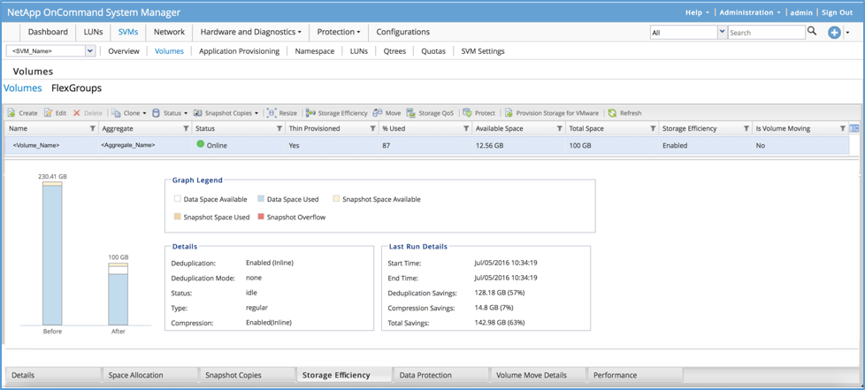

* My AutoSupport:

Volumes tab under My AutoSupport AFF Efficiency Calculator

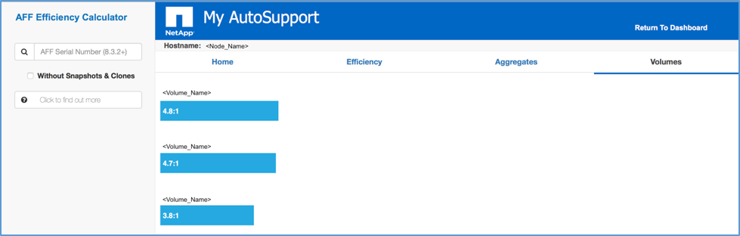

1. Aggregate:

* CLI:

‘aggr show-efficiency’ command that is available in Advanced mode.

<Cluster>::*> aggr show-efficiency -aggregate $AGGR_NAME

                       Name of the Aggregate: <$AGGR_NAME>

                Node where Aggregate Resides: <$NODE_NAME>

Logical Size Used by Volumes, Clones, Snapshot Copies in the Aggregate: 17.56TB

                         Total Physical Used: 2.74TB

              Total Storage Efficiency Ratio: 6.42:1

          Logical Space Used for All Volumes: 3.06TB

         Physical Space Used for All Volumes: 2.47TB

         Space Saved by Volume Deduplication: 362.1GB

           Space Saved by Volume Compression: 174.7GB

Space Saved by Inline Zero Pattern Detection: 59.72GB

              Volume Data Reduction SE Ratio: 1.24:1

         Logical Space Used by the Aggregate: 2.76TB

        Physical Space Used by the Aggregate: 2.74TB

         Space Saved by Aggregate Compaction: 28.62GB

           Aggregate Data Reduction SE Ratio: 1.01:1

        Logical Size Used by Snapshot Copies: 14.45TB

       Physical Size Used by Snapshot Copies: 197.7GB

      Logical Size Used by FlexClone Volumes: 91.17GB

    Physical Sized Used by FlexClone Volumes: 60.61GB

Snapshot And FlexClone Volume Data Reduction SE Ratio: 57.66:1

                   Number of Volumes Offline: 1

              Number of SIS Disabled Volumes: 19

   Number of SIS Change Log Disabled Volumes: 46

* OnCommand System Manager:

Efficiency tab under Hardware and Diagnostics -> Aggregates window in OnCommand System Manager

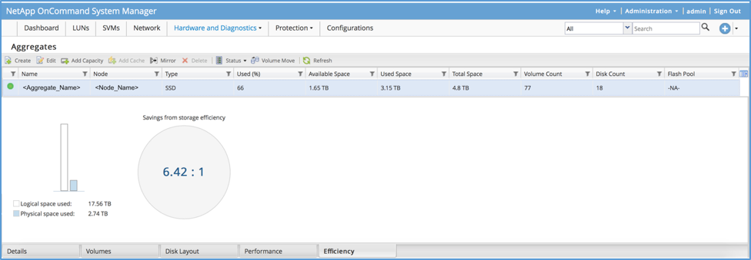

* My AutoSupport:

Aggregates tab under My AutoSupport AFF Efficiency Calculator

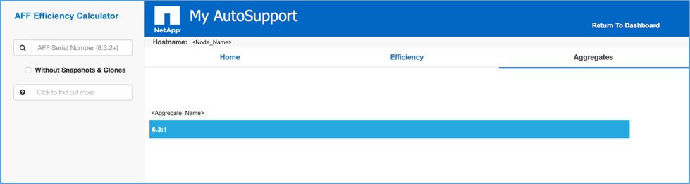

1. Node:

* OnCommand System Manager:

‘Efficiency’ tab under ‘Efficiency and Capacity’ dashboard

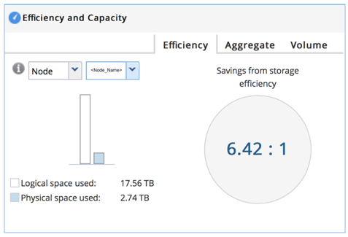

* My AutoSupportNode view under My AutoSupport AFF Efficiency Calculator:

1. (You can get to this view by clicking on Logical/Physical space used details from My AutoSupport AFF Efficiency Calculator homepage)

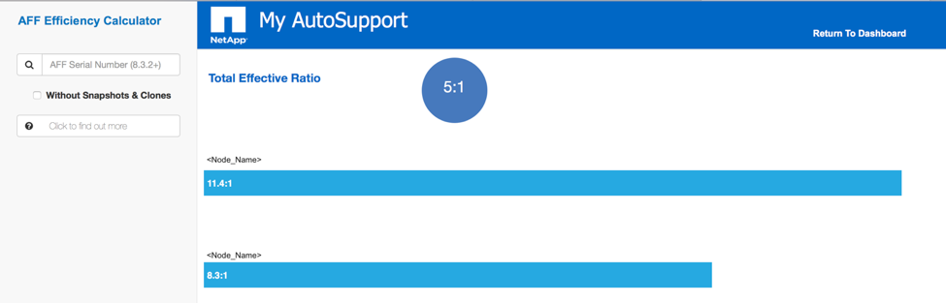

1. Cluster:

* OnCommand System Manager

‘Efficiency’ tab under ‘Efficiency and Capacity’ dashboard

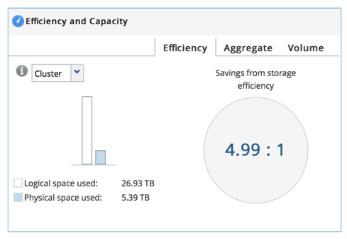

* My AutoSupportEfficiency tab under My AutoSupport AFF Efficiency Calculator homepage

